Ideation Phase
Define the Problem Statements

Date | 18 JUNE 2026
Team ID
Project Name | Online Complaint Registration System
Maximum Marks | 2 Marks

Customer Problem Statement:
The Online Complaint Registration & Management System is designed to address the challenges faced by citizens and administrators in complaint handling. Citizens often struggle to register complaints, track their status, and receive timely updates regarding resolution. At the same time, administrators and officers face difficulties in managing, assigning, and monitoring complaints efficiently using traditional manual methods.
This project aims to provide a centralized digital platform that enables users to submit complaints, track complaint status, receive updates, and provide feedback after resolution. The system also allows administrators and officers to efficiently manage complaint assignments, update statuses, and monitor overall complaint resolution performance. By improving transparency, accessibility, and communication, the solution enhances the overall complaint management process and user satisfaction.

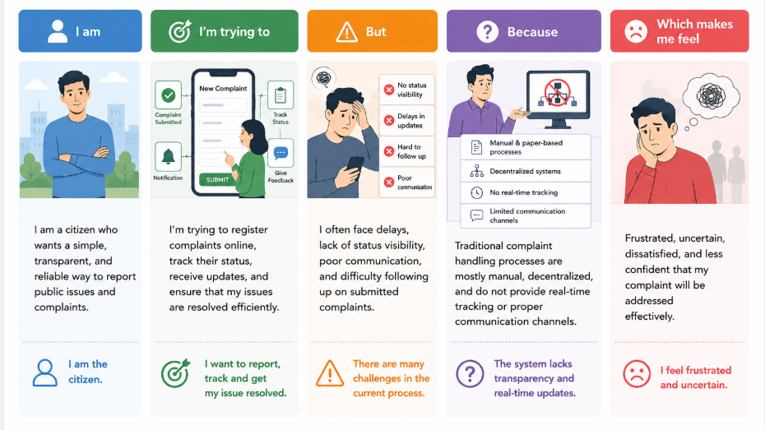

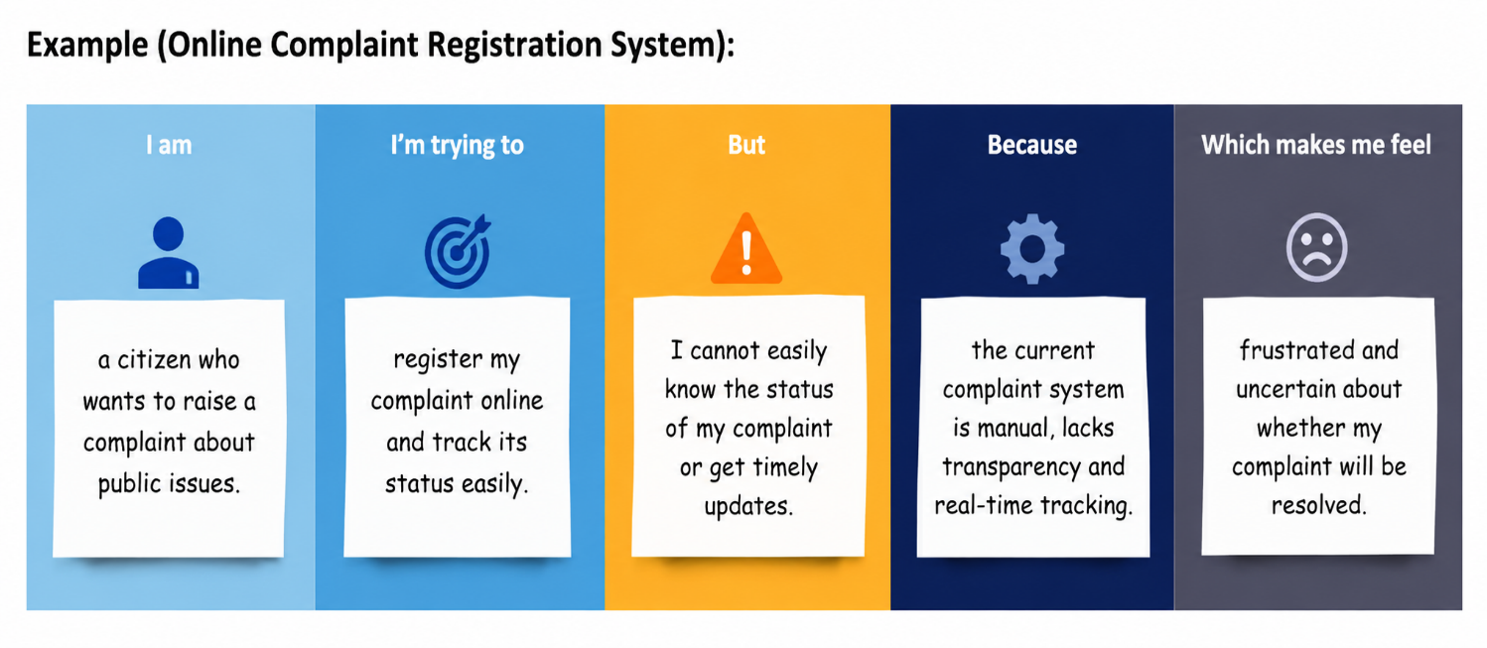

Problem Statement (PS) | I am (Customer) | I'm trying to | But | Because | Which makes me feel
PS-1 | A citizen | Register and track my complaint online | I cannot easily know the complaint status | Traditional complaint systems lack transparency and real-time updates | Frustrated and uncertain

Problem Statement (PS) | I am (Customer) | I'm trying to | But | Because | Which makes me feel
PS-2 | An administrator/officer | Manage and resolve complaints efficiently | It is difficult to monitor and assign complaints manually | There is no centralized complaint management platform | Overloaded and inefficient

